**Unit 3 – Activity 6**

**Miniature Golf**

You and a friend decide to work on your short game in Putt-Putt miniature golf.

You play 4 different holes. Each hole provides a different acceleration due to the length of the grass on the putting green.

You get to choose where to place the ball and will attempt your putt from that location.

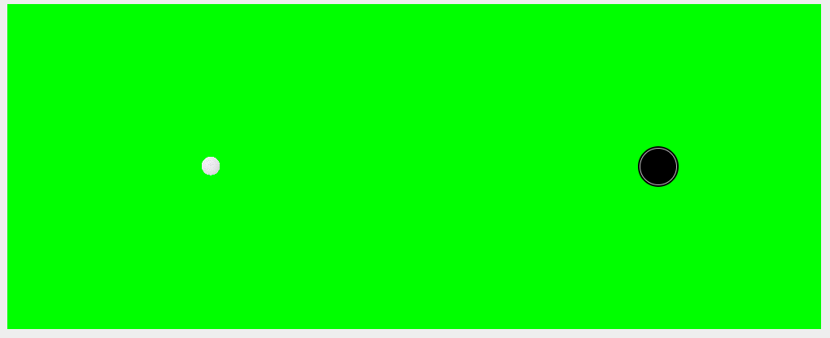

The good news is that your reading of the green is superb but getting that initial velocity on the ball is a challenge.

* Hitting it too lightly and the ball won’t make it to the hole!
* Hit it too hard and the ball will skip right over the top!

Each hole has a different quality of grass, resulting in four different accelerations. As such, you must alter your next-v function to take acceleration as an input. Open the code found here: <https://tinyurl.com/y7mxwecs>. For each hole, on your whiteboard:

1. Describe your initial position of the ball.
2. How did you determine how hard to hit the ball?
3. Which green had the longest grass? What is your evidence?